Name: Soh Hong Yu  
Class: DAAA/FT/1B/01  
Admin No: P2100775

# Tables created

# New endpoints

Remove item from cart

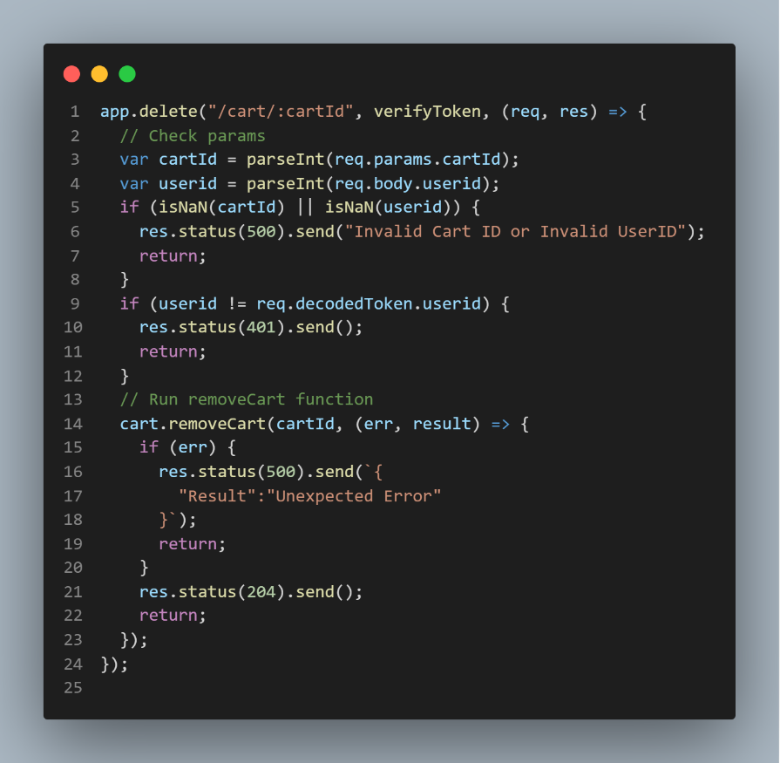

Delete category

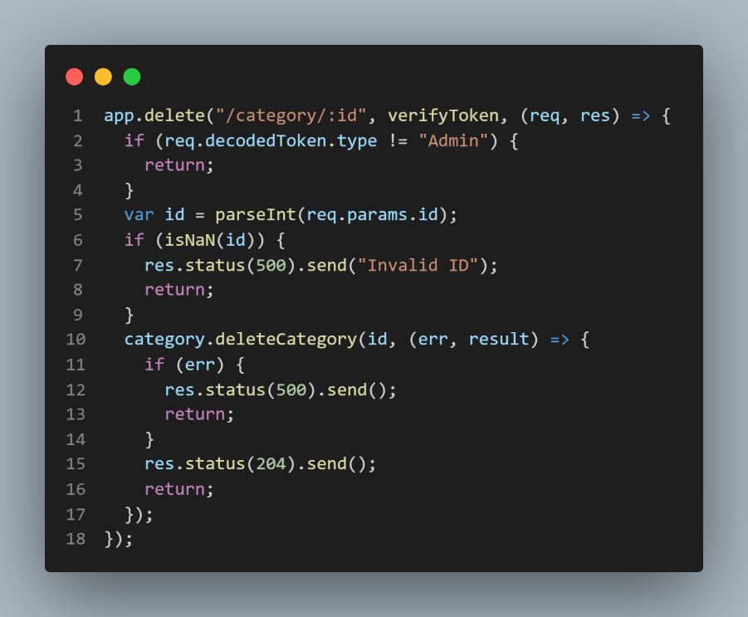

Delete interest

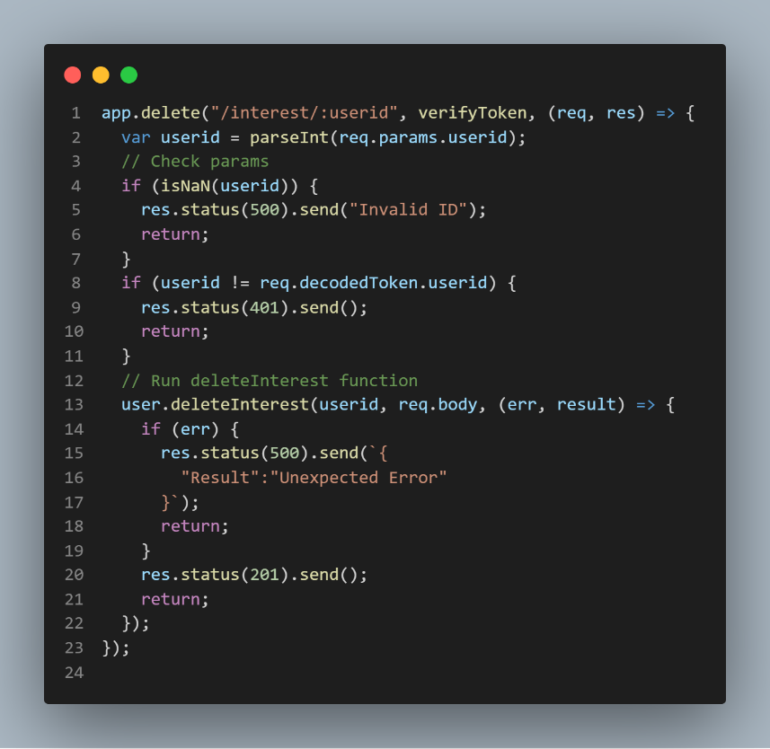

Update product – Included verifyToken and changed Product Image uploading

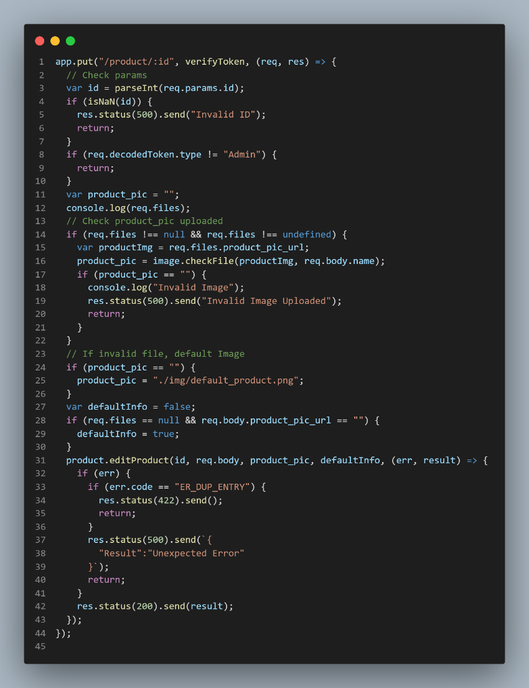

Filter by ID

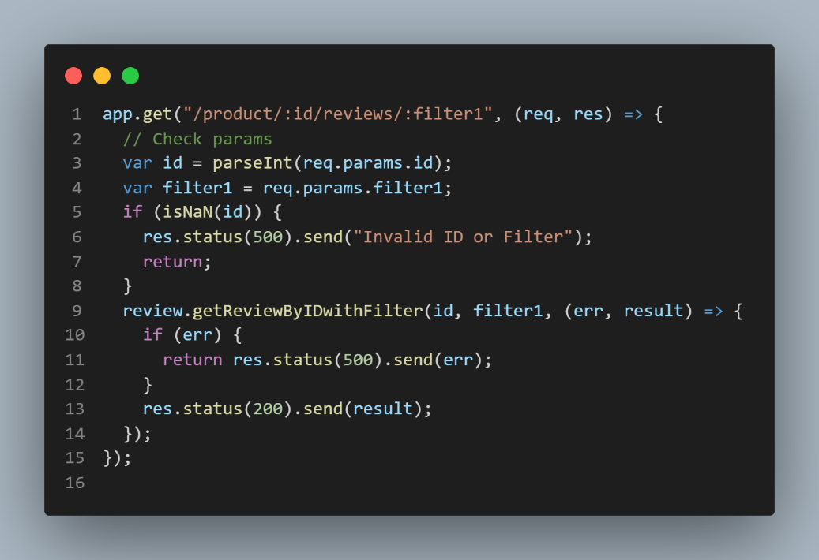

Get all products

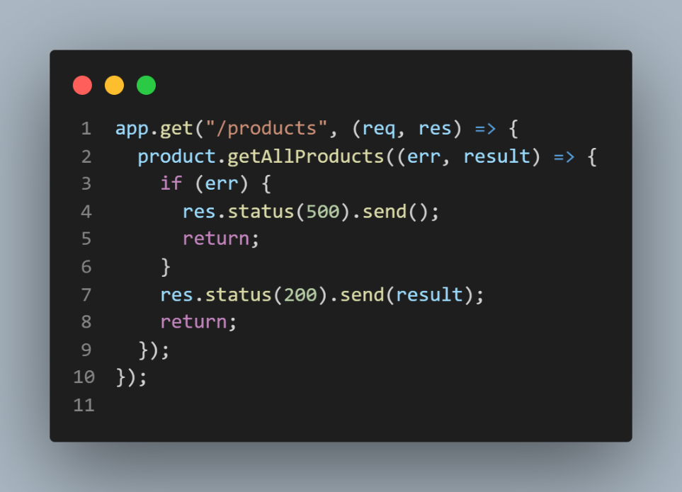

Get interest by userid

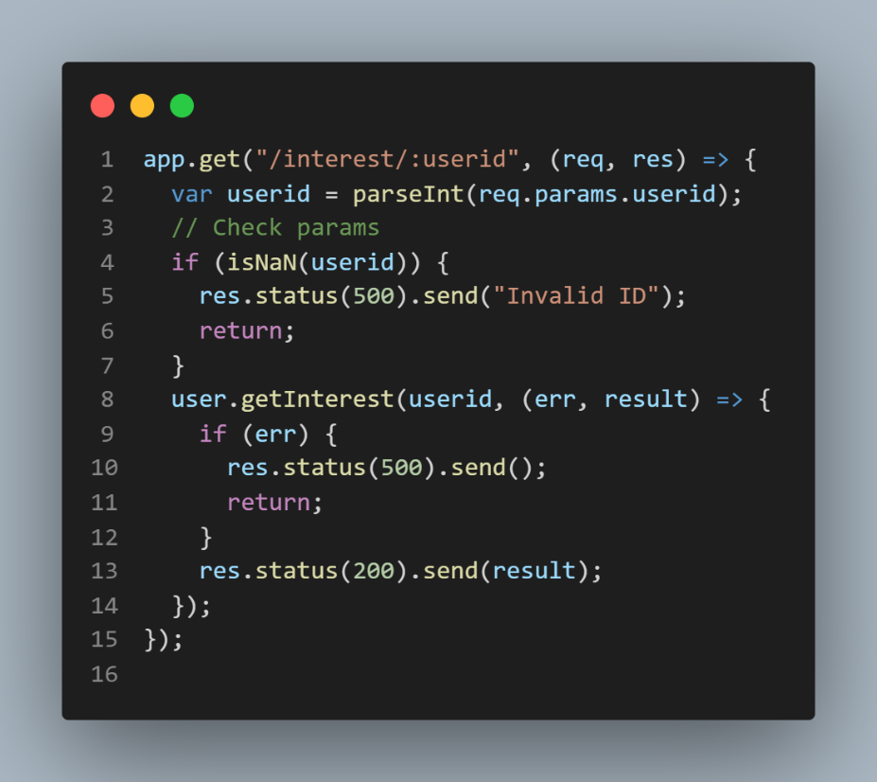

Get products by categoryid

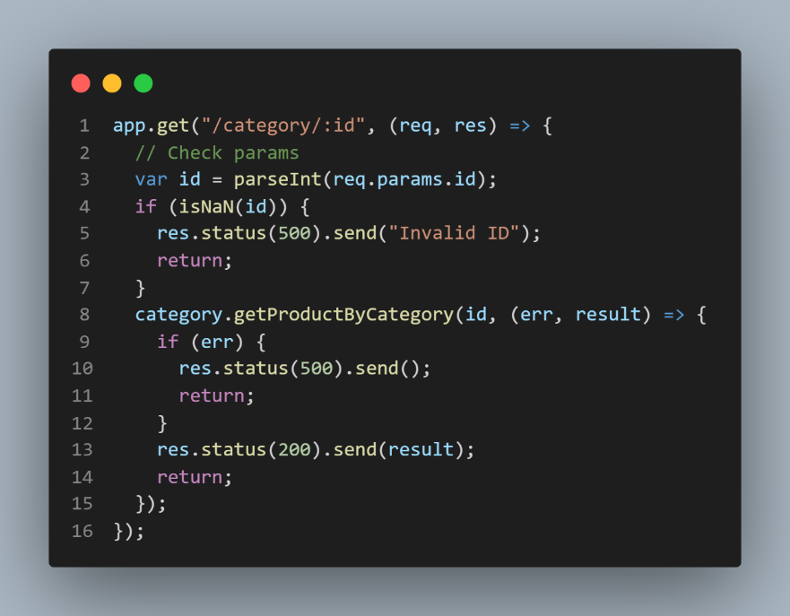

Image Endpoint – created an endpoint for image showing

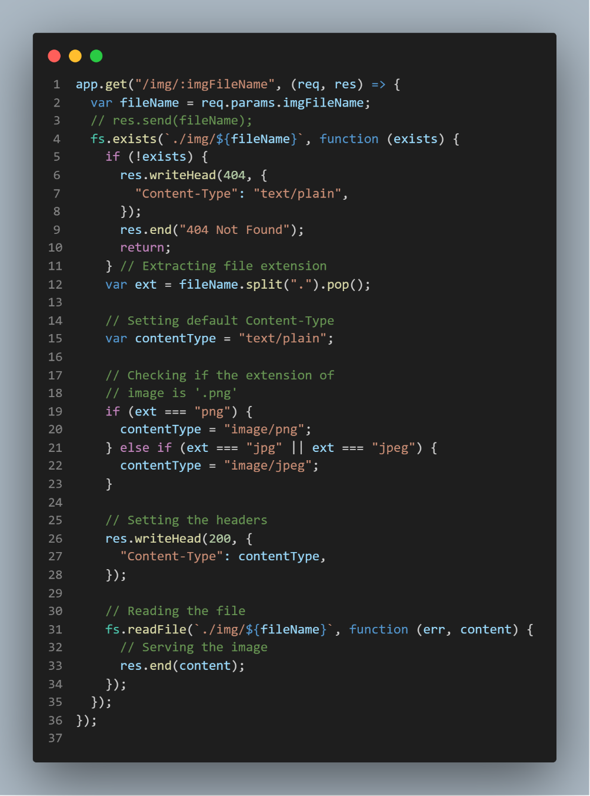

Post new promo – added images and verifyToken

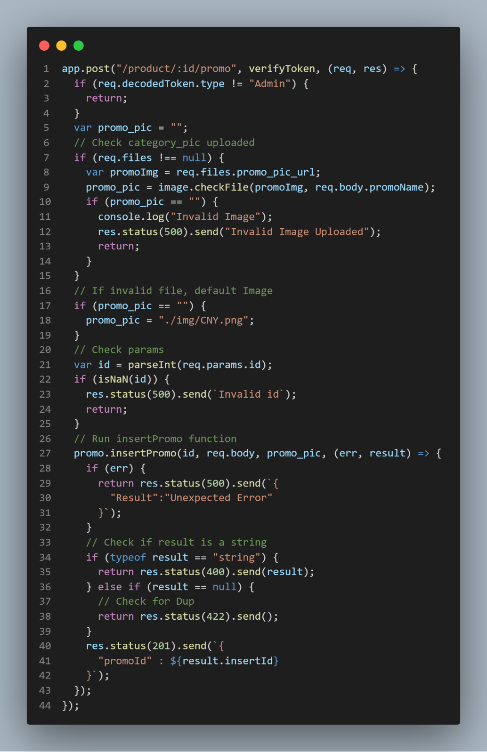

Login Endpoint with JWT signing

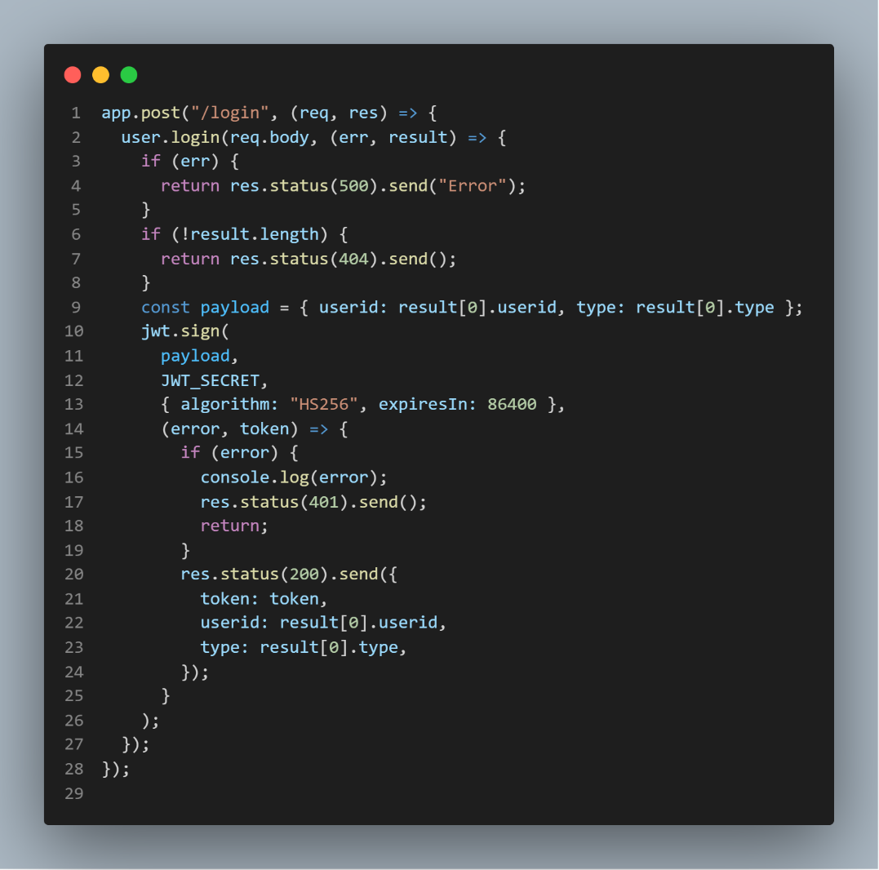

Get user’s part purchases

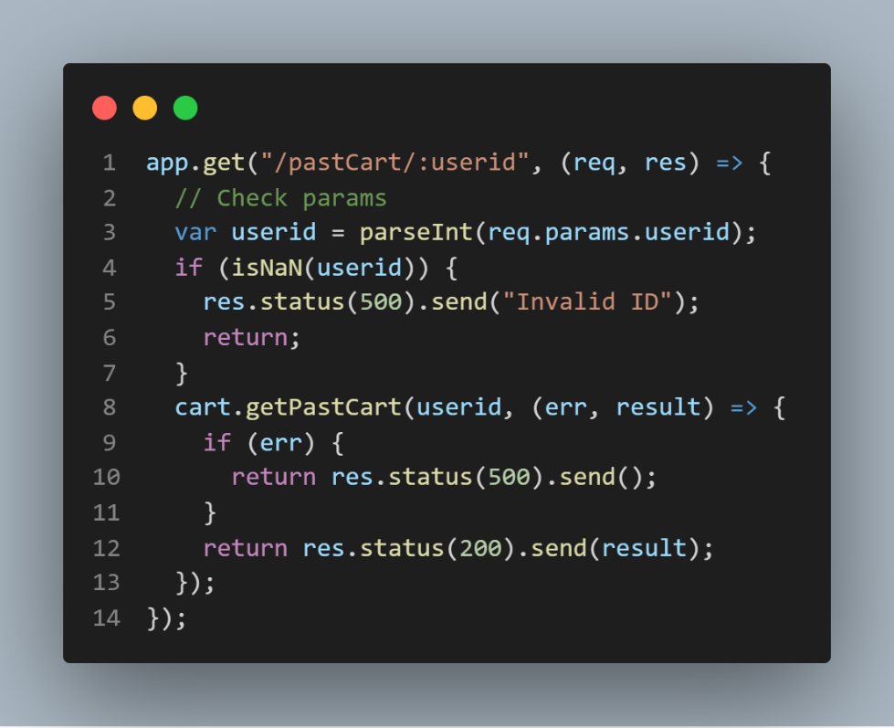

Get random products – order by rand()

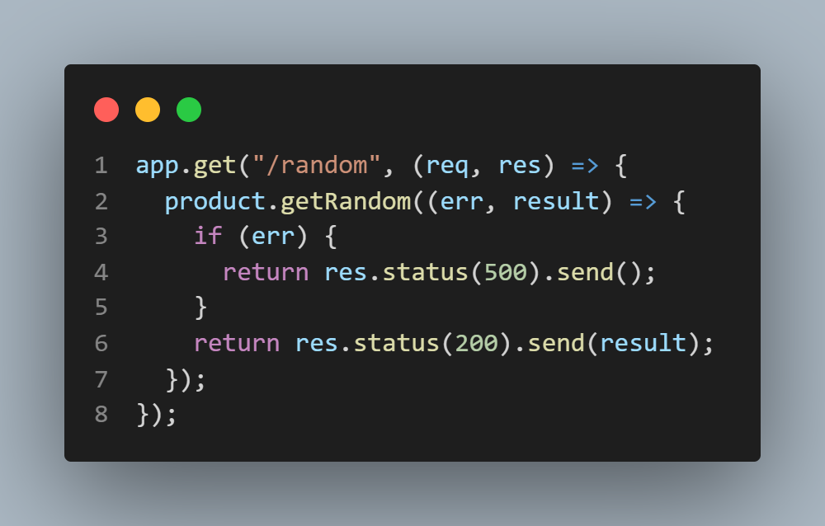

Get random product by category – recommend products if they interested – order by rand()

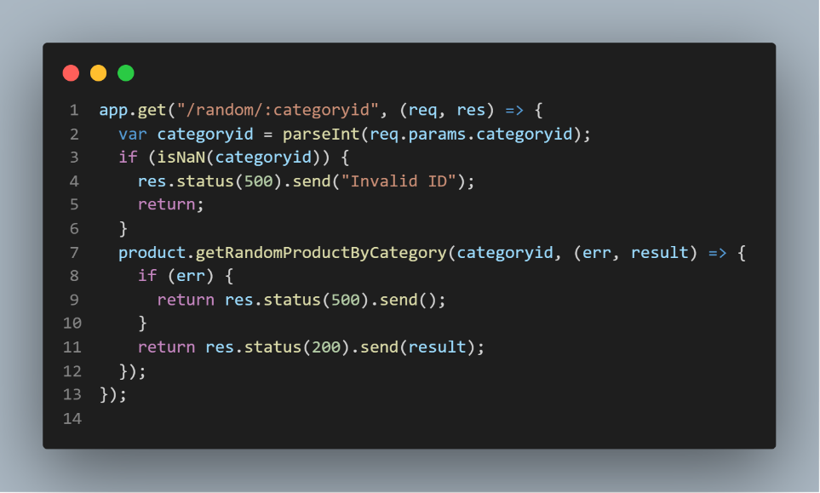

Search endpoint

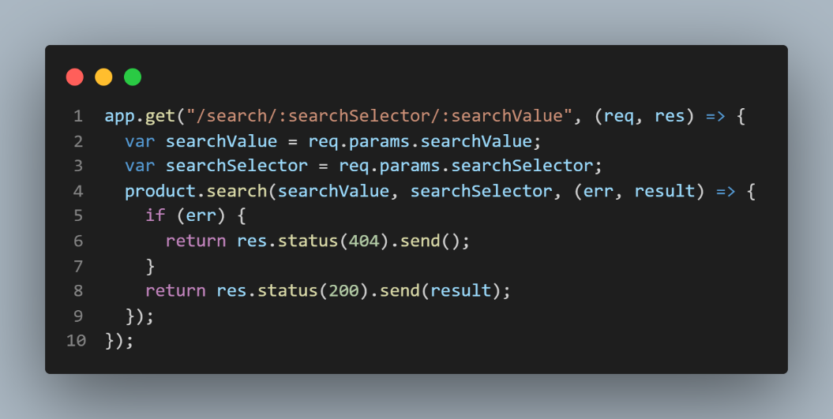

Checkout user and add to past purchase

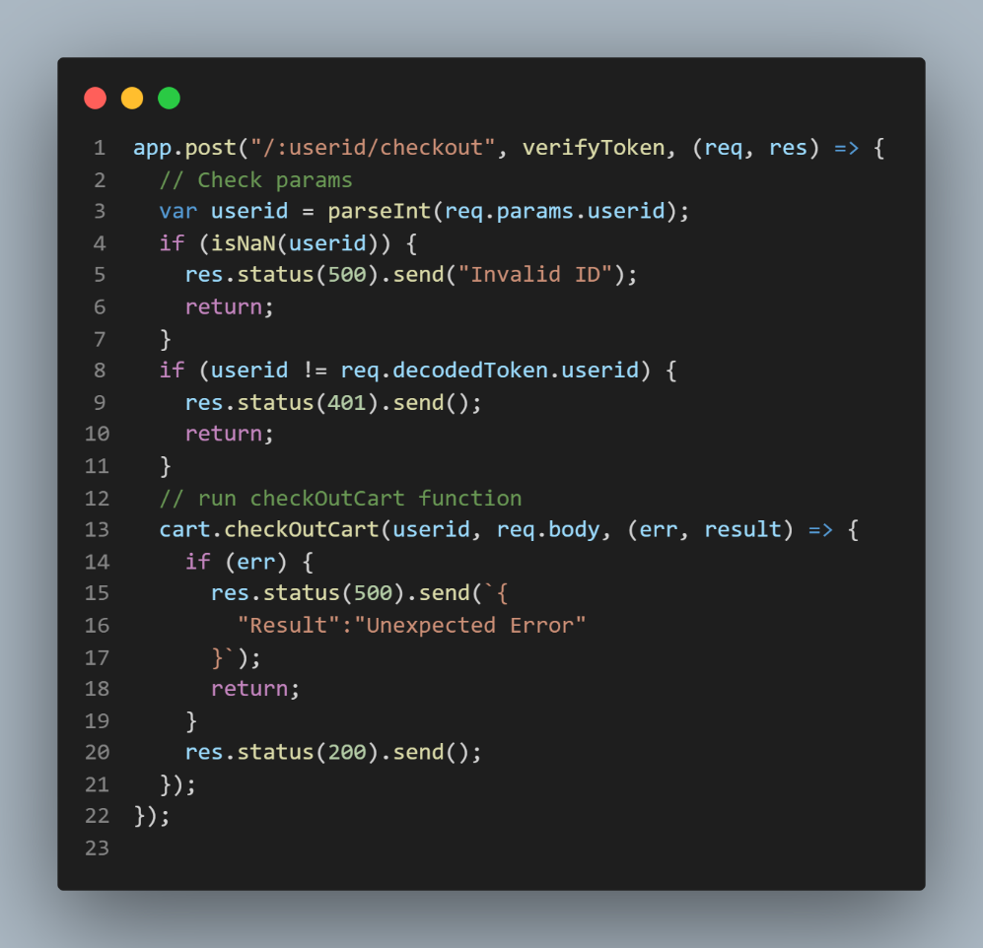

Update Cart quantity

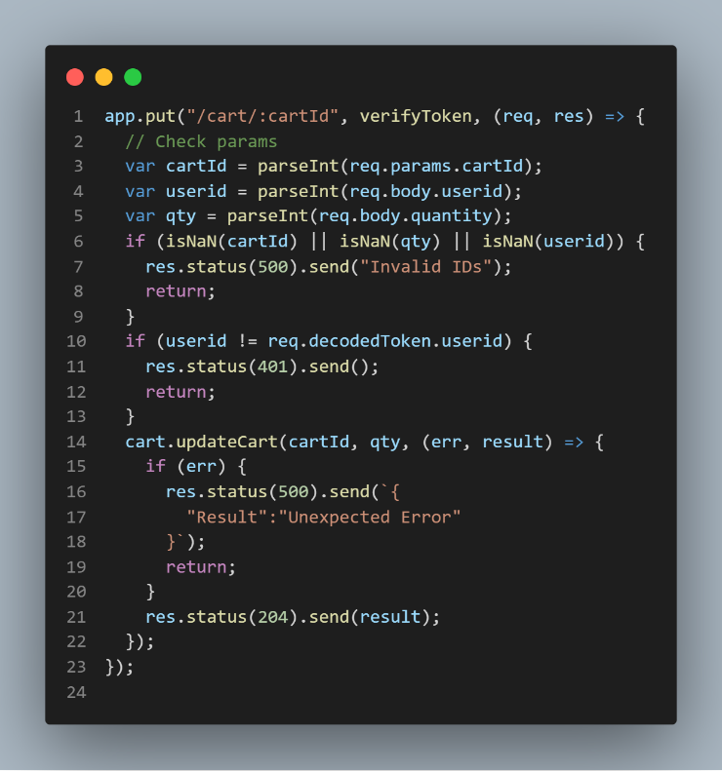

Update category by id – add verifyToken and check if user is currently an admin.

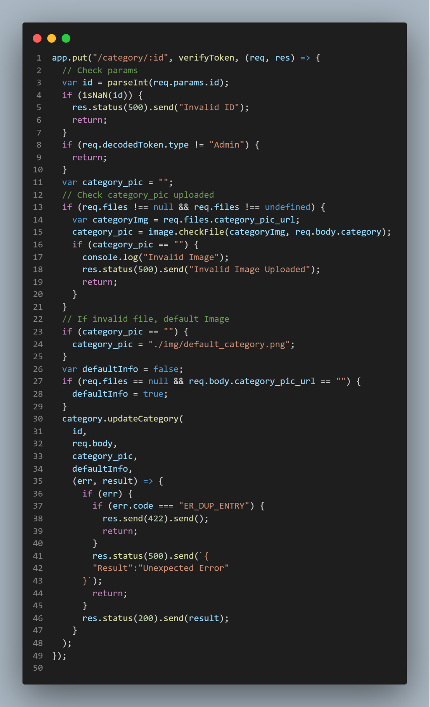

Update promo by id – verifyToken && image value if err, 500, if invalid date, 400 else 200

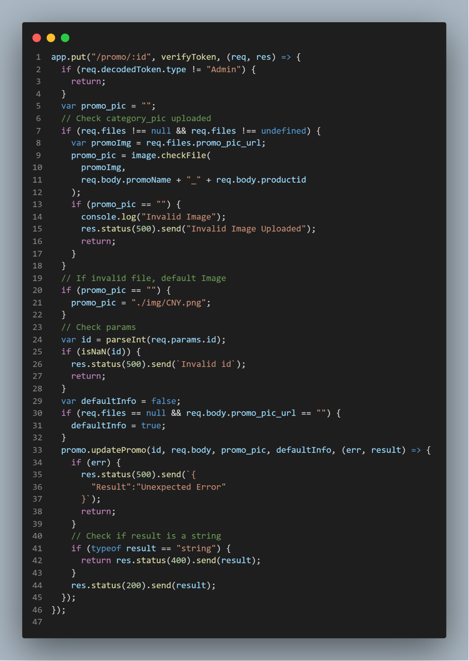

Update product review – include verifyToken. If there is an error send 500 else 204 No Content

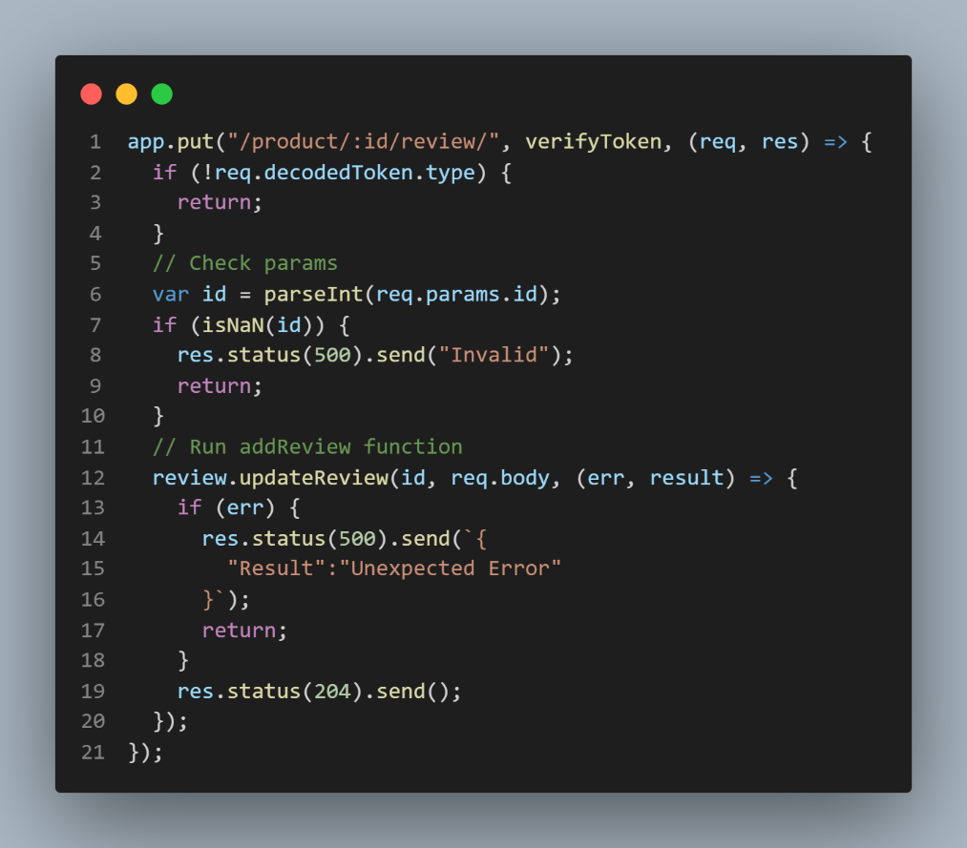

JWT Token – verifyToken code to get the encoded userid and type from token.

How to setup:   
1. Open run sql init in workbench

2. cd into the client directory and npm i

3. cd into the server directory and npm i

4. cd into client directory and npm start

5. cd into server directory and npm start

6. search <http://localhost:3000/>